# **Product Based Insights**

## **Historical Analysis by Product Category:**

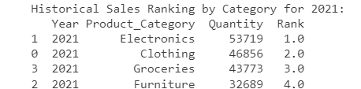

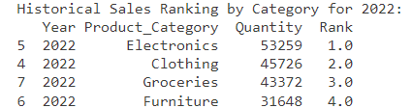

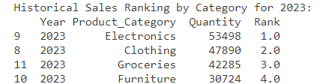

* Electronics is the highest selling category since last 3 years as per given dataset with Clothing, Groceries and Furniture following.

## **Forecast Analysis by Product Category (Prophet Model):**

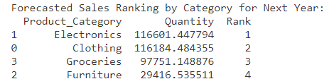

* Electronics is the highest selling category for coming year with Clothing, Groceries and Furniture following.

## **Historical Analysis by Product Name:**

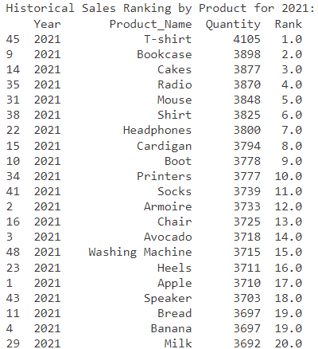

* T-shirt is the highest selling product in year 2021

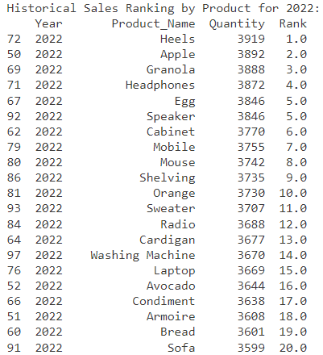

* Heels is the highest selling product in year 2022

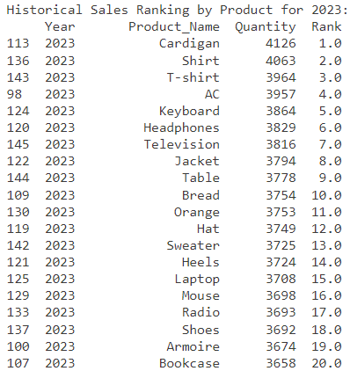

* Cardigan is the highest selling product in year 2023

## **Forecast Analysis by Product Name for Year 2024 (Prophet Model):**

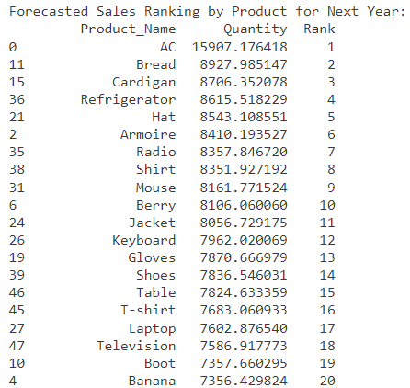

* AC is the highest selling product for coming year 2024 followed by Cardigan, Laptop…

## **Factors and Model Affecting to Predict the Sales:**

### Historical Sales Data (Quantity column)

**Sales Volume:** The past sales volume data (Quantity) is the core input to the Prophet model, influencing its understanding of trends and seasonality.

### Temporal Factors

**Time Series Data:** The ds column in the Prophet model, which includes the date information derived from the Year column, is essential for identifying temporal patterns.

**Seasonality:** Prophet detects and models yearly and, optionally, other forms of seasonality present in the historical sales data.

### Trend Detection

**Long-Term Trends:** Prophet identifies, and projects long-term trends based on the historical data, which helps in understanding the general direction of sales (upwards or downwards).

**Short-Term Changes:** Recent changes in sales patterns also impact the trend component of the model.

### Forecasting Model Characteristics (Prophet)

**Additive Model:** Prophet uses an additive model where the observed value is a sum of the trend, seasonality, and holiday components.

**Automatic Outlier Detection:** Prophet can automatically detect and adjust for outliers in the historical data.

**Flexibility:** It can accommodate missing data and shifts in the time series.

### Calendar Effects

**Holidays and Special Events:** While not explicitly modeled in your code, Prophet allows the inclusion of holidays and special events that can significantly impact sales.

### Data Preprocessing Steps

**Datetime Conversion:** Converting the Year to datetime format is crucial for time series analysis.

**Data Aggregation:** Aggregating data by year, category, and product ensures that the model receives structured and relevant inputs.

### Model Parameters

**Default Prophet Parameters:** Prophet comes with a set of default parameters for detecting seasonality and trends. Customization of these parameters can further refine the forecast.